Mirroring Unified Metadata as THE Solution for The Digital Library Network at Developing Countries

Case Study: The Indonesian Digital Library Network

Ismail Fahmi)

Abstract

The typical problems that arise when we develop digital library network at developing countries are internet accessibility, bandwidth capacity, and network delays. These cause some digital library network architectures will not work; such as mediation architecture and centralized data warehousing. A short report on the development of the Indonesian Digital Library Network is presented, with its architecture – mirroring unified metadata – as the solution. The status of the network is described that show the successfulness of the architecture in tying together partner’s knowledge from all big islands of Indonesia (Sumatera, Java, Kalimantan, Sulawesi, and Irian Jaya) whether they have dedicated internet connection or only a dial-up one. Currently 13 institutions have joined the network and 15+ in progress of developing their servers. Features of the software, Ganesha Digital Library (GDL version 3.1) are presented, that is now distributed as a Free-Software that is based on MySQL, PHP, and Apache.

1. The Indonesian Digital Library Network

The Indonesian Digital Library Network, IndonesiaDLN, is the first digital library network in Indonesia, http://idln.itb.ac.id. The development was pioneered and motored by Knowledge Management Research Group (KMRG) at Institut Teknologi Bandung (ITB) Indonesia, together with other librarians and information engineers. This work was carried out with the aid of a grant from the International Development Research Centre (IDRC) Canada and the Indonesian Foundation for Telecommunication and Information Research (YLTI) for the period of 2000-2002. Other organization that support this work are Asian Internet Interconnection Initiative (AI3) ITB, ITB Central Library, and Computer Network Research Group (CNRG) ITB.

KMRG ITB has started research on the digital library network since 1998. Then establishment of the IndonesiaDLN forum was initiated at October 2000. The first operation of the network was launched at June 2001.

The mission of IndonesiaDLN is to unlock knowledge of Indonesian people – especially the local content -- and share it nationally. It means to provide information about Indonesia such as about their final project, theses, dissertation, research report, heritage, regional potency, history, etc in an easy way, user friendly, distributed, and invite contribution from Indonesian people widely. Such information will be very useful to increase nation’s information literate, collaboration among them, and to promote Indonesia to international.

IndonesiaDLN has a wide range of partners such as from research, education, business, NGO, government, etc. This will create a big national knowledgebase that should be maintained and organized again becoming more useful information package series. For example we could make series of children education, theses and dissertation, national heritage, human right and democratic, etc.

IndonesiaDLN is to be said as a mother network of digital library network in Indonesia. It is because there will be many networks connected to IndonesiaDLN.

There is as a hub that will unify all metadata from all digital library networks in Indonesia. Currently there are two networks of digital library joined within IndonesiaDLN, namely GDL-Network and NS-Network.

1.1. GDL-Network

GDL-Network is network of digital library servers that use Ganesha Digital Library (GDL) software as their server application. GDL is developed by KMRG ITB as one of its research outputs funded by IDRC and YLTI. It is developed using PHP scripting language, MySQL database server, and Apache web server. GDL is distributed as a free-software and the source code can be downloaded at http://gdl.itb.ac.id/download/.

Currently, GDL is the most widely used application by IndonesiaDLN partners. The same source code can be installed for three types of partners: Institution, Personal, and Internet Cafe. Contribution from the partners can be viewed at http://gdlhub.indonesiaDLN.org.

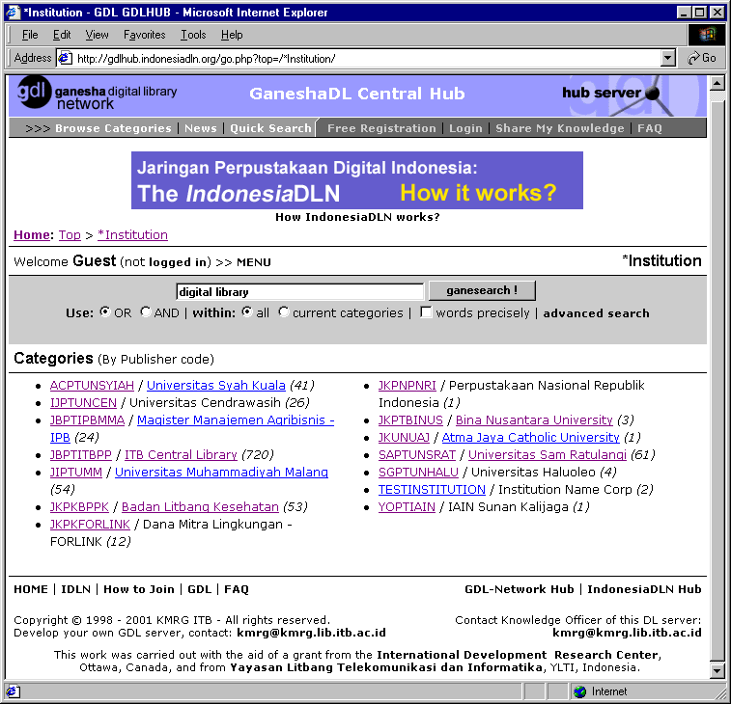

Figure 1. The gateway to IndonesiaDLN’s partners collection, http://gdlhub.indonesiaDLN.org.

1.2. NS-Network

NS-Network is network of digital library servers that use New Spektra (NS) as the server application. NS is developed by University of Petra Surabaya Indonesia especially for their Christian university consortium members.

1.3. Other Efforts

There are several other digital library efforts in Indonesia such as by KMNRT, LIPI, etc. In the future IndonesiaDLN also will support information about heritage, human right, and agricultural.

By using the standardized interoperability metadata, we hope can integrate the digital libraries into one national digital library network.

2. Data Integration

There are two methods of data integration: global defined from local and global independent from local. While the first can be implemented using Database Schema Integration, and the second using Data Warehousing or Data Intermediation [4]. The most relevant method with IndonesiaDLN condition is the second one, where in the future database structure of partners’ digital library will be different.

Figure 2. Paradigm of data integration (taken from Ibrahim’s slide [4]).

Data Warehousing will collect all data of interest in a central place and a web site is built on top of it. It is easy to support queries and transaction, but hard to modify because the warehouse is not connected to the providers.

Data Intermediation will reroute queries to the sources. Data remains in web sources so that data are guaranteed to be up-to-date.

3. Internet Infrastructure at Developing Countries

Both architectures (data warehousing and data intermediation) require good internet connection that often difficult to be found at most area of developing countries. For example, students at University of Irian Jaya difficult to find a good internet access to send queries to ITB digital library server. This cause data warehousing or data intermediation that is implemented at ITB will not answer their need.

In Indonesia, only few of research and education institutions have dedicated internet connection. Most of them only have a dial-up or even have no connection at all.

But now we can find internet kiosks that are growing around the places. It is a good situation where we can consider it as a positive factor in designing digital library network at developing countries, especially in Indonesia.

4. Mirroring Unified Metadata Architecture

Considering above conditions, we should design architecture of the digital library network that can answer our need of access to the sources of information. Problems such as internet bandwidth, availability, and access can be solved by bringing the information sources close to the users.

Using this paradigm, users don’t have to send their queries to the publishers’ servers but to the nearest mirror server. This will make the queries to be processed and the response to be received fast. Figure 3 describes architecture of this paradigm.

Figure 3. Mirroring unified metadata architecture.

From above figure we can see that there are a Hub Server (global) and many Partner Servers (local). Partner server will manage partner’s full content files with their metadata, while the Hub server will manage metadata from all partners and full content files from some partners especially from partner with non-dedicated internet connection.

Regularly, partners will synchronize metadata of their ‘public’ accessible collections to the Hub, using HTTP or SMTP protocol. Partners also can ‘mirror’ their full content files to the Hub using HTTP protocol. This mirroring is useful especially for partners that don’t have dedicated internet connection. Their collections will remain on the Hub so that users still can download and access their collections even though the local servers are not online.

To serve their users, partners can ‘download’ selected or whole metadata from the hub using HTTP or SMTP protocol. During the synchronization process, the metadata will automatically extracted and stored into local metadata table. Then, users can search, browse, and read metadata from all partners locally. Users don’t have to visit the hub server or to every partner’s server in order to find information they need. We mirror the unified metadata at the hub server into our local server [2].

Because the full content files are still remaining at partners or hub servers, users have to download directly from the source servers. They can use dial-up connection or order via email.

Partners can do the synchronization whether they use dedicated internet connection, dial-up, or even their servers behind a proxy. Of course partner should also mirror their files into hub server if their connections are not dedicated.

5. Synchronization Services

Synchronization will be done at partner side. Figure 4 describes the services required during the synchronization.

Figure 4. IndonesiaDLN synchronization services

The services are grouped into three functions; AUTHENTICATION, PUT, and GET. Authentication is required by partner’s server before synchronize metadata. Every partner has its Publisher_ID and Publisher_SerialNo that are registered and generated by the Hub.

PUT protocol requests are facilities for partner to send its metadata or files to the Hub. Partner also needs to register its members to the Hub. This registration is required in order the members are able to get access to other partners server without have to do registration many times.

GET protocol requests are facilities for partner to get the unified metadata from the Hub. The metadata from all other partners then will be stored into its local database. Partner also can get publishers information from the Hub. This information is needed by users to contact publisher of the displayed metadata.

6. Interoperability Metadata Standard

Metadata format at local server could be independent from the global. To overcome this metadata format differences, we have declared a metadata standard called “IndonesiaDLN Interoperability Metadata Standard” [2]. This standard was derived from NDLTD (Networked Digital Library of Theses and Dissertation, Virginia Tech) interoperability metadata standard [3].

Both standards are using the Dublin Core Metadata Element Set [1]. Selection of Dublin Core as the adopted standard is a right choice because it will open further international collaboration on digital library network.

All digital library servers at IndonesiaDLN should use this standard for the synchronization. The synchronization protocol at local server will do the metadata conversion from local metadata format to the standard metadata interoperability format, and vice versa.

7. XML-based Transaction

Metadata, publisher, and member data are formatted in XML during transaction between partner and hub. This method will open wider collaboration with other digital library and distance learning efforts to build one big national digital library network.

For example, publisher record for the HUB is formatted like figure 5.

<?xml version="1.0"?>
<INDONESIADLN>
<DC.PUBLISHER>
GaneshaDL Central Hub
<ID>GDLHUB</ID>
<TYPE>INSTITUTION</TYPE>
<APPS>GDL</APPS>
<ORGNAME>Knowledge Management Research Group ITB</ORGNAME>
<HOSTNAME>gdlhub.indonesiaDLN.org</HOSTNAME>
<IPADDRESS>167.205.23.27</IPADDRESS>
<PROTOCOL>HTTP</PROTOCOL>
<ADMIN>donfau@kmrg.lib.itb.ac.id</ADMIN>
<CKO>cko@kmrg.lib.itb.ac.id</CKO>
<POSTMASTER>pm@digilib.itb.ac.id</POSTMASTER>
<CONNECTION>DEDICATED</CONNECTION>
</DC.PUBLISHER>
</INDONESIADLN>

Figure 5. Example of XML format for Publisher data

8. Status of IndonesiaDLN

The application that is currently used by IndonesiaDLN partners is GDL, the Ganesha Digital Library version 3.1. Other application, New Spektra, is under development and will be released soon.

There is one hub server at IndonesiDLN namely GDL-Hub. This hub is used to manage metadata exchange from partners that use GDL as their digital library application.

Currently there are 13 institutions that have been successfully connected and share their metadata to GDL-Hub, namely:
- ACPTUNSYIAH / Universitas Syah Kuala (dedicated)
- IJPTUNCEN / Universitas Cendrawasih (dial-up)
- JBPTIPBMMA / Magister Manajemen Agribisnis - IPB (dedicated)
- JBPTITBPP / ITB Central Library (dedicated)
- JIPTUMM / Universitas Muhammadiyah Malang (dedicated)
- JKPKBPPK / Badan Litbang Kesehatan (dedicated)
- JKPKFORLINK / Dana Mitra Lingkungan - FORLINK (dial-up)
- JKPNPNRI / Perpustakaan Nasional Republik Indonesia (dial-up)
- JKPTBINUS / Bina Nusantara University (dedicated)
- JKUNUAJ / Atma Jaya Catholic University (dedicated)
- SAPTUNSRAT / Universitas Sam Ratulangi (dedicated)
- SGPTUNHALU / Universitas Haluoleo (dial-up)
- YOPTIAIN / IAIN Sunan Kalijaga (dial-up)

Every partner has its unique Publisher_ID as listed above. Publisher_ID contains area code, type of library, and the publisher abbreviation name. There are more than 15 institutions developing their server, and then will join IndonesiaDLN. Beside implementation of GDL for institution, we also release other GDL edition for Personal and Internet Kiosk. This configuration then creates a network called GDL-Network as shown by figure 6.

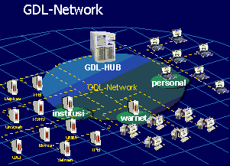

Figure 6. GDL-Network configuration consists of institutions, internet kiosks, and personal.

9. Future: IndonesiaDLN as Mother of Digital Library Networks

There are other efforts such as the Digital Heritage Network, SME/ Agriculture Network, Human Right Information Network, and Bibliographic Network. All of these networks can be integrated under IndonesiaDLN easily as long as they use IndonesiaDLN Interoperability Metadata Standard for exchange.

Figure 7. Architecture of IndonesiaDLN as Mother of digital library networks

From figure 7 above we can see many networks can be integrated into one big network, IndonesiaDLN. For this purpose, GDL will be developed modularly. The main part is GDL-Engine that will provide facilities of the web-based digital library services.

The services would be: membership, authentication, search engine, content browsing, and the exchange protocol. The most important service is the exchange protocol.

10. Important URL

[1] IndonesiaDLN official web site, http://idln.itb.ac.id

[2] Ganesha Digital Library web site, http://gdl.itb.ac.id

[3] GDL-Hub, gateway to IndonesiaDLN partners, http://gdlhub.indonesiadln.org

[4] Download GDL 3.1 source code, http://gdl.itb.ac.id/download/

[5] IsisOnline, current online bibliography databases, http://isisonline.lib.itb.ac.id/

11. References

[1] DC, Dublin Core Metadata Element Set, Version 1.1, 1999, http://purl.org/dc/documents/rec-dces-19990702.htm.

[2] FAHMI, Ismail, Team, Standard Interoperabilitas Metadata Untuk Pertukaran Metadata Karya Elektronik di Lingkungan IDLN, 2000, http://idln.itb.ac.id/meeting/Oktober2000/interoparability_metadata_standar_idln.htm.

[3] FOX, Edward, Interoperability Metadata Standard for Electronic Theses and Dissertations -- version .02, 2000, http://www.ndltd.org/standards/metadata/current.html.

[4] IBRAHIM, Ismail Khalil, Data Integration in Digital Libraries: Approaches and Challenges, 2001.

*) Ismail Fahmi, Ir. Graduated from undergraduate program of Electrical Engineering Department of ITB on 1997. His interests are on network management, knowledge management, and digital library. He is a researcher at Computer Network Research Group ITB (CNRG), the Asian Internet Interconnection Initiatives ITB (AI3), the head and founder of Knowledge Management Research Group ITB (KMRG), general secretary of IndonesiaDLN, and head of Knowledge Resource Development Foundation. He is the designer and creator of GDL version 1 until 3.1, and with his team is now preparing for GDL 4.0, SME/Agri Network, Human Right Networking, and Digital Heritage Network. He can be reached at ismail@itb.ac.id, or http://netmon.itb.ac.id/~ismail/.

Head of Knowledge Management Research Group, ITB, Indonesia.

