ITB Central Library Contribution:
Concept, Strategy, and Technology for Future Indonesian Libraries

IITELMIT, JCC 30 June 2000

This paper presents the development of concept, strategy, and technology for future Indonesian libraries that have been being developed by Knowledge Management Research Group of ITB Central Library.

The concept is based on Digital Library and Knowledge Management. The aim is to leverage the Intellectual Capital of an organization (education and research institution).

By:
Ismail Fahmi (ismail@itb.ac.id)
Knowledge Management Research Group (KMRG)
ITB Central Library

Agenda:

[1] Knowledge Management Project, ITB Central Library

[2] Knowledge Management at a Glance

[3] Ganesha Digital Library, Managing Intellectual Capital
of ITB Community

[4] Digital Library Network For Research Reports, Theses,

and Dissertations

[5] ISISNetwork, One Stop Shop for Libraries Services

[6] GNU-Lib, Free-Software for Library Automation

[1]
Knowledge Management Project
ITB Central Library

© 2000, Knowledge Management Research Group (KMRG) ITB

Vision:
Toward the development of a knowledge-based society, through an effective management of our local Intellectual Capital, and using any low cost and appropriate information technology.

Knowledge-based society
is an environment where its communities share their knowledge each other for a better life.

Strategies:
- Using low cost information technology, such as utilization of Free-Software or Open-Sources (Unix FreeBSD, Linux, etc).
- Develop a low cost and useful Digital Library software, and make it Free.
- Capture ITB’s Intellectual Capital (Final Project, Theses, Dissertations, Research Reports, etc) and provide presentation and access in digital format via Internet to the communities.
- Share the technology to other educational and research institutions, and develop a Digital Library Network with them.
- Promote the idea and invite communities to join the knowledge-sharing society.

[2]

Knowledge Management
at a Glance

From “The Knowledge Management Year Book 1999-2000”

© 2000, Knowledge Management Research Group (KMRG) ITB

The explicit knowledge as we find everyday is like a top of an iceberg where the tacit knowledge reside under the surface. Managing the tacit knowledge becomes very important and strategic for organizations.

What is Knowledge Management?
Knowledge Management can be defined as:
- Identification
- Optimization
- Active management,

of intellectual assets, either in the form of:
- explicit knowledge held in artifacts or
- tacit knowledge possessed by individuals or communities.

Explicit Knowledge
The optimization of explicit knowledge is achieved by the consolidation and making available of artifacts.

Tacit Knowledge
The optimization of tacit knowledge is achieved through the creation of communities to hold, share, and grow the tacit knowledge.

Knowledge Management
The active management of intellectual assets is the creation of management processes and infrastructure to bring together artifacts and communities in a common ecology that will sustain the creation, utilization, and retention of intellectual capital.

These activities to intellectual capital are important for organizations that wish to survive and prosper into the next decade and beyond.

What are the objectives of a Knowledge Management Project?
- Create knowledge repositories
Three basic types of repositories:
    - external knowledge, such as competitive intelligent
    - structured internal knowledge, such as research reports, product-oriented marketing materials, techniques and methods
    - informal internal knowledge, like discussion databases full of know-how.
- Improve knowledge access
Provide access to knowledge or facilitating its transfer among individuals. “Get at the knowledge we know we have” and “share our knowledge”.
- Enhance knowledge environment
Establish an environment conducive to more effective knowledge creation, transfer, and use. Build awareness and cultural receptivity to knowledge, initiatives attempting to change behavior relating to knowledge, and improve the knowledge management process.
- Manage knowledge as an assets
Thread knowledge like any other asset on organization’s balance sheet to improve return.

What are indicators of a successful Knowledge Management project?
- Growth in the resources attached to the project, including people, money, and so on.
- Growth in the volume of knowledge content and usage.
- The project would still survive without the support of a particular individual. It means that the project is an organizational initiative, not depend on individual.
- Some evidence of financial return either for the knowledge management activity itself (e.g. become profit center) or for the larger organization.

How to success in a Knowledge Management projects?
- Build a Knowledge-Friendly Culture, where:
  - People have a positive orientation to knowledge
  - People are not inhibited in sharing knowledge
  - The knowledge management project fits with the existing culture
- State your Clear Purpose and Language.
The term – “knowledge,” “information,” “organizational learning,” “data” – are subject to varied use and interpretation. Pay attention to this factor for your organization.
- Use Multiple Channels for Knowledge Transfer.
- Give Senior Management Support, in the form of:
  - Sending messages that knowledge management and organizational learning are critical to the organization’s success.
  - Providing funding and other resources for infrastructure.
  - Clarifying what types of knowledge are most important to the organization.

[3]
Ganesha Digital Library,
Managing Intellectual Capital of ITB Community

© 2000, Knowledge Management Research Group (KMRG) ITB

Vision:
Toward an Intellectual Capital information center of ITB, by effectively managing the tacit and explicit knowledge of individuals in ITB community, using low cost and appropriate information technology, and open access to our nation for knowledge sharing through the Internet.

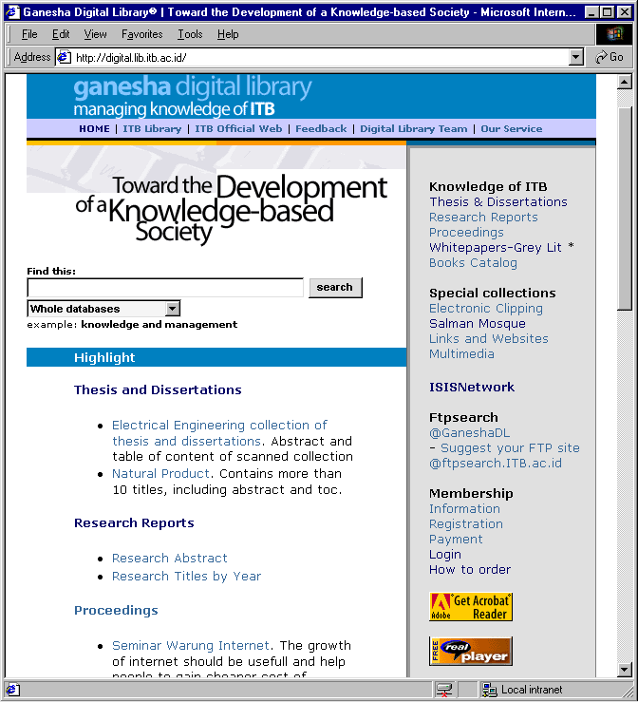
Strategies:
- Mapping the Intellectual Capital of ITB.
- Capturing the explicit knowledge and manage them in digital format.
- Provide Expertise Directory for tacit knowledge to enable direct knowledge transfer with the individuals.
- Setup policy, rule and procedure for individuals to submit their explicit structured knowledge.
- Open online access for ITB community, our nation, and globally via the Internet.

Knowledge Map of ITB’s Intellectual Capital:
Explicit:
- Course material: courses information, exam materials, course references in digital format.
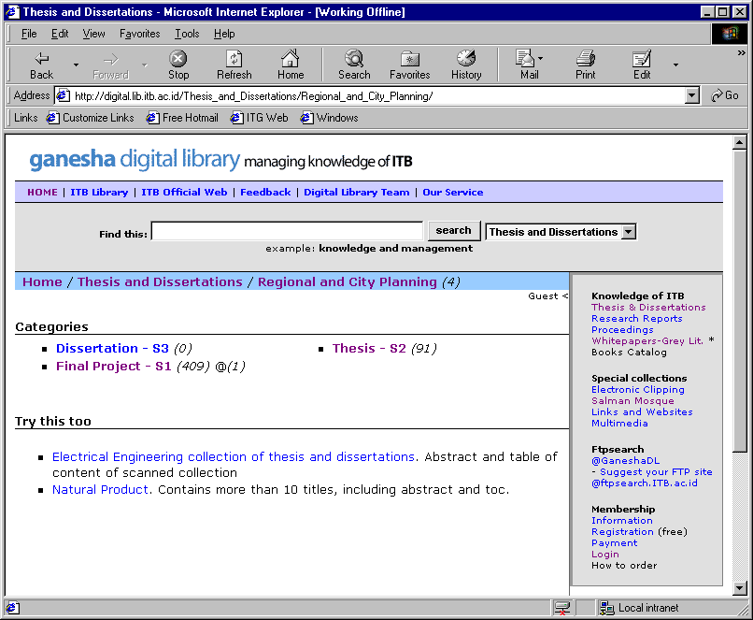
- Individual or groups knowledge: Final project reports, Theses, Dissertations, Research Reports, and papers.
- Publication: internal journals, bulletin, etc.
- Proceeding from seminar, workshop, studium general within ITB.
- Multimedia, converted into digital format:
  - audio and video cassettes collection of ITB Central Library (events, history, language learning, etc)
  - speech cassettes collection of Salman Mosque

Tacit:
- Directory of expertise: individual, groups, and departments profiles.
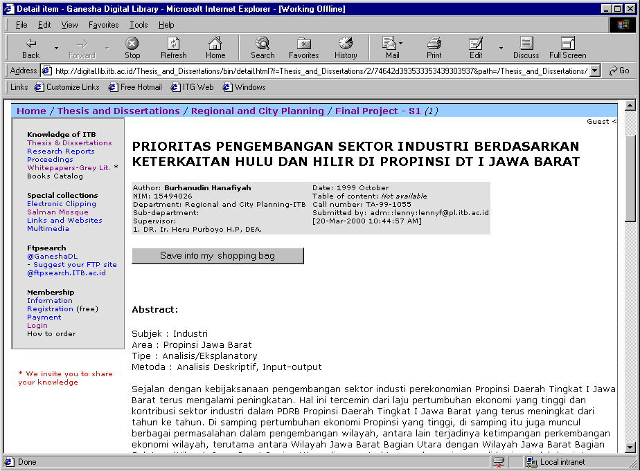
- Mailing list archives.

External Knowledge
- Web portal to other science and technology related sites.
- International Journal for Intranet online access (full text).

URL
http://digital.lib.itb.ac.id

Network Topology

Server Configuration
Current configuration of Ganesha Digital Library server is as follow:
Server Hardware | Pentium 100  64 MB Memory  8 GB HD
Operating System | Unix FreeBSD
Application servers | Web server: Apache+PHP  Database: MySQL  Index server/search engine: ISIS-FreeWAIS and FTPSearch  Multimedia server: Real server  Mail server: Qmail

[4]

Digital Library Network
For Research Reports, Theses, and Dissertations

Improving Graduate Education and Upgrading the Utilization of Research Results

© 2000, Knowledge Management Research Group (KMRG) ITB

Objectives
This project focuses on two segments of communities:
- The students as a critical community in the world of higher education and the researchers as the most creative and innovative community.
- The libraries as a knowledge archive, organizer, and distributor to serve the first community.

Accordingly, the general objectives of this project will be:
- Information about research results will be more easily and widely (national and international) available.
- Publishing the research results will be faster, easier, and cost effective.
- The quality of graduated students and their research results will be upgraded.
- The utilization of research results by students and researchers – also by business, industry, and public – will be increased.
- The tacit knowledge sharing and processing will be facilitated so that scholarly discussion among students and researchers will upgrade their knowledge.
- At the next phases: Linkage between education-research institutions and community of business, industry and public will be increased and will produce many new beneficial impacts for national development.

Project Beneficiaries

Community of Producers: higher education students and researchers

The benefits they will obtain from this project are:
- Easy of searching and finding other research results related to their concern, whether online or off-line (using CD-ROM).
- Increase their information literacy.
- Easy of publishing their research results electronically (including metadata and full text).
- Earn royalties from any utilization of their research reports.
- Possibilities of further collaboration between the author and business, industry, or public segments that interested on their research results.
Community of Users: Libraries

This community acts as the knowledge archive, organizer, and distributor produced by the first community and in turn will serve the needs of the community to upgrade their information literacy and to support further knowledge construction.

The benefits libraries will obtain from this project are:
- Have a technology (GPL license) to serve their communities.
- Get a technical support to maintain and operate the system.
- Have a network (community of libraries) to exchange knowledge.

On the next phase, benefits also will be obtained by communities such as business and industries. The benefits they will obtain from the further phases of this project are:
- Easy access on the research results from academic and research institutions.
- Possibilities of finding solution from academic and research institutions’ point of view for their needs.
- Easy access on the expertise information among academic and research institutions toward the further mutual collaboration.

Project Methodology

The methodology for this project will consist of the following activities:
- Evaluate the existing technology that freely available on internet.
- Involve the library community by bringing together the participants to construct the required standards and rules of the networked digital library, such as developing standard of metadata, submission process, copyright, royalty, file naming, etc.
- Develop a new appropriate application of networked digital library of research reports, theses, and dissertations based on the existing technology.
- Construct an agency to manage the operational and administration of the system.
- Hold a test bed and then operate the central server of the system.
- Socialize the system amongst higher education students, lecturers, and researchers, and train them on how to use the system (searching, retrieving, make submission, take advantage).
- Disseminate the research information collected in the central server whether in the form of on line digital library or off-line CD-ROM.
- Construct a course material of training and distance learning for user and administrator of the system.
- Disseminate the system to be implemented by partner organizations.
- Hold a test bed that performs information exchange between the central server and other servers.
- Provide technical support and coordination during the growth of the system nationally.
- Evaluate and monitor the progress of the system.

Project Outputs

The following is a table of this project’s outputs.

No | Output Description | Type | Dissemination
1 | Tools or application of the networked digital library with the following functions:  - submission,  - search, browse, and retrieve the stored research reports  - information exchange between servers in the networked digital library  - additional facilities to manage the tacit knowledge | Software | Make it freely available on internet, using GNU/GPL license.  Need coordination with the agency for the implementation and joint to the network.
2 | Standards, for example: metadata, file naming, submission process, file format, etc. | Standard | Available on web site.
3 | Rules of the agency for the management of operation and administration of the system. | Standard | Available on web site.
4 | Database of research results including full text. | Database and full text | Online digital library web site and CD-ROM.

Partner Organizations
- Eastern Indonesia Universities Development Project (EIUDP, the CIDA’s project):
  - University of Cendrawasih (UNCEN)
  - University of Samratulangi (UNSRAT)
  - University of Pattimura (UNPATTI)
  - University of Haluouleo (UNHALU)
- Pasca Sarjana ITB
- Research Institute of ITB (LP ITB)
- ITB Central Library (Digital Library)
- PDII LIPI Jakarta
- University of Brawijaya Malang Central Library
- University of Muhammadiyah Malang Library
- IAIN (Institute of Islamic Religion, supported by McGill University Canada):
  - IAIN Sunan Ampel Surabaya
  - IAIN Sunan Kalijaga Yogyakarta

Supporting Organizations
- Asian Internet Interconnection Initiatives (AI3) ITB
- Computer Network Research Group (CNRG) ITB

Funding Organizations
- Institute of Technology Bandung
- International Development Research Centre (IDRC), waiting confirmation.
- Indonesian Foundation of R&D for Telecommunication and Information Technology (YLTI).
- Computer Network Research Group (CNRG)
- Contribution from each partners.

Example Scenario

[5]
ISISNetwork,
One Stop Shop for Libraries Services

Enable online communication and transaction between individuals and librarians for libraries services

© 2000, Knowledge Management Research Group (KMRG) ITB

What is CDS/ISIS?
CDS/ISIS is a software of library’s catalogues database that is developed and maintained by UNESCO for libraries in developing countries. Most of libraries in Indonesia use this software to manage their bibliographic information and other collections.

A low cost but great software for library automation has been developed by Institute of Agricultural Bogor (IPB) Library and based on this CDS/ISIS platform. It is called SIPISIS. Contact: mus@ipb.ac.id

What is WAIS/ISIS?

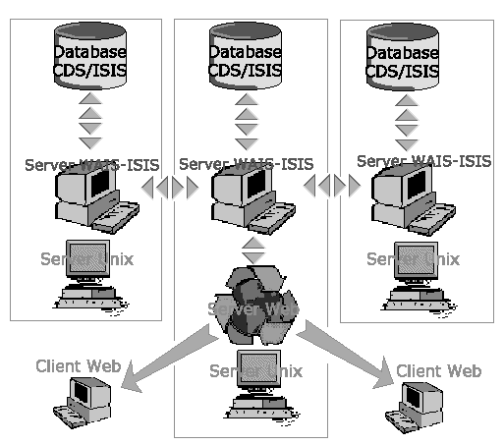
WAIS/ISIS is a Free-Software that running on Unix box (FreeBSD or Linux) that able to search the indexed CDS/ISIS database directly, without any conversion, so that the database can be accessed from the Internet.

The advantage of WAIS/ISIS compared to other CDS/ISIS-to-Web-Gateway software is its capability to communicate between WAIS/ISIS servers, so that we can develop a network of CDS/ISIS database servers.

What is ISISNetwork?
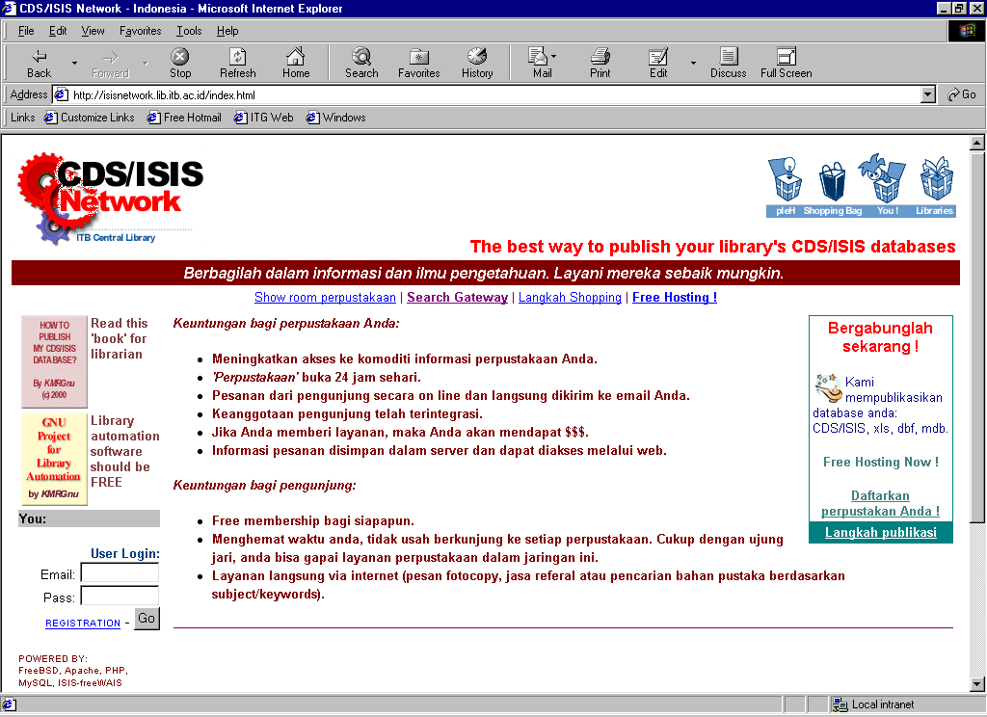
ISISNetwork is a service that is developed by KMRG ITB within ITB Central Library. It provides CDS/ISIS databases publication to Internet for Indonesian Libraries that are facilitated with online Shopping (online-order).

Currently, there are 11 libraries host their CDS/ISIS database at ISISNetwork server of ITB Central Library, and more than 40 databases can be accessed from the Internet.

The Internet address of ISISNetwork is http://isisnetwork.lib.itb.ac.id.

What services provided by ISISNetwork?
There are two types of services provided for Indonesian libraries:
- Free CDS/ISIS Hosting
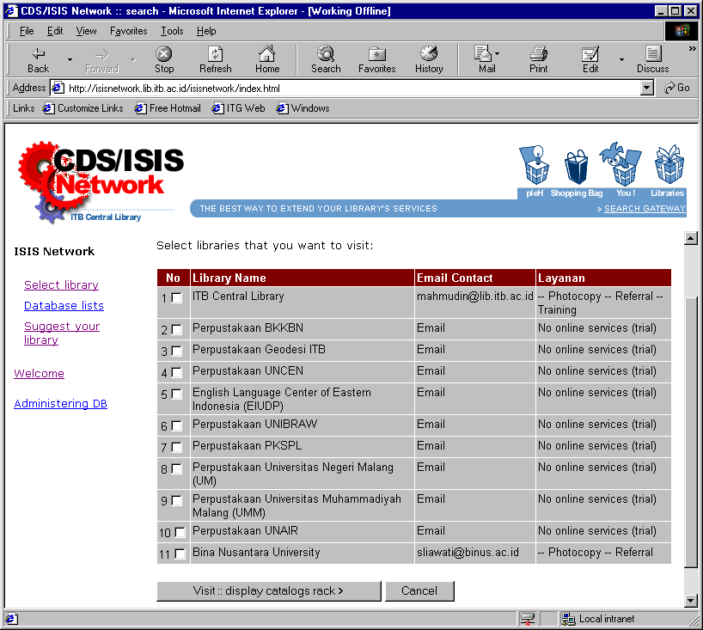
Your library’s CDS/ISIS databases could be freely hosted at ISISNetwork server with unlimited space. People from the Internet will be able to search your CDS/ISIS databases.

This service has no online order feature.

- Full Hosting
With full hosting service, your library page will be created including contact address, payment information, and connected to our membership database.

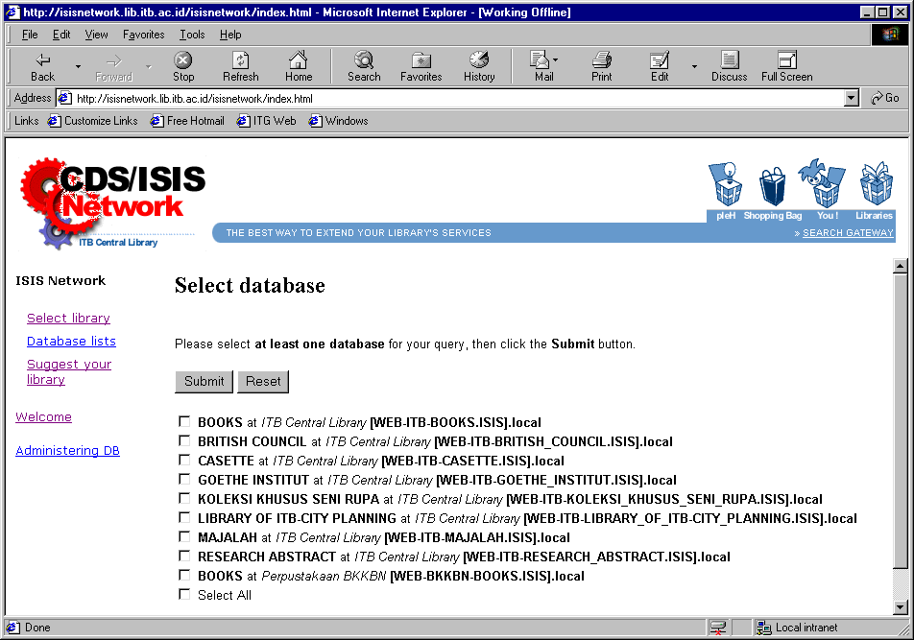
The advantage of this service is your library will be able to give online service to users for example information finding and photocopying parts of collection.

How libraries visiting and databases searching works?
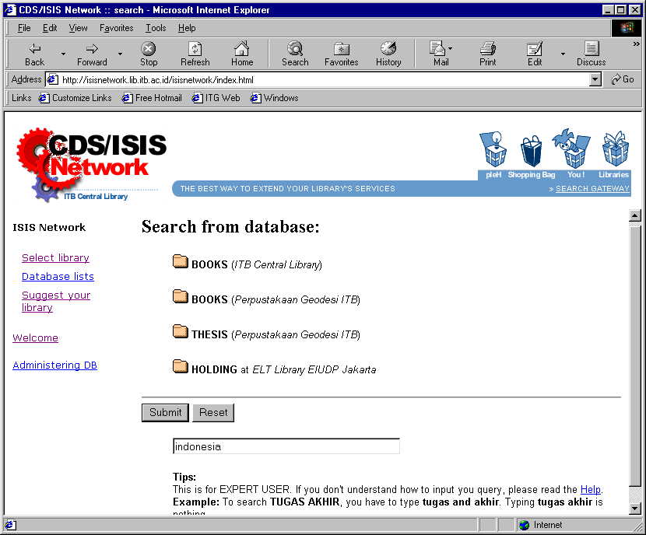
- First, user will select libraries that s/he wants to visit. Then the list of databases owned by the libraries selected will appear.
- User selects databases that s/he wants to search. Then a search form will appear against the selected databases.
- User inputs their question. Then the server will search the query against the selected databases, and display the result to user web browser.
- User clicks one of the results to see the detail of catalog information.
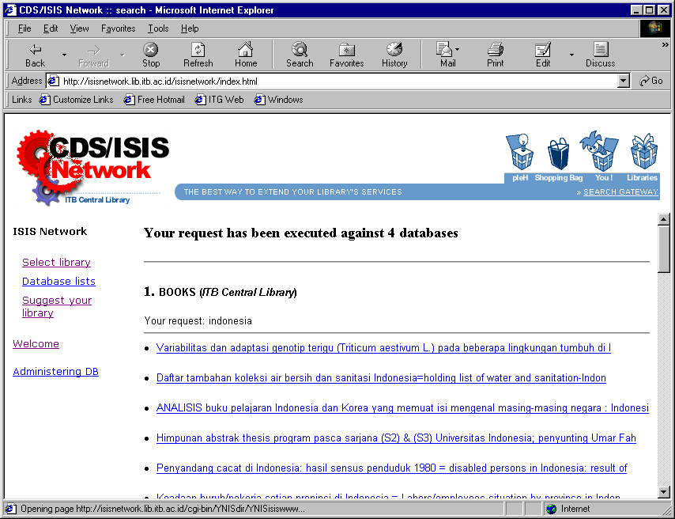
How online order works?
- After user found information item from your CDS/ISIS database, s/he can send order via web browser. S/he also can type additional information such as number of pages to be copied or other keyword to be searched by the librarian.
- The ISISNetwork server will automatically send the orders to your librarian via email.
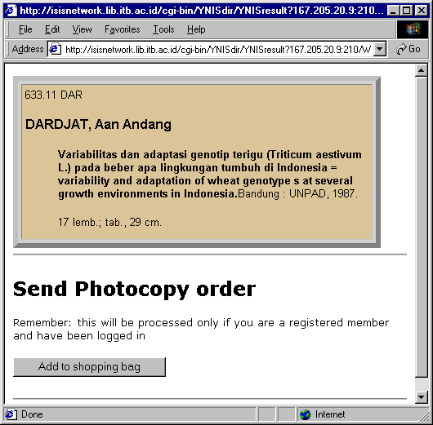
- Your librarian will check the email, process the order, and send feedback to user via email to give information for example whether the requested order can be processed, found, etc.
- If needed, your library can ask user to pay some money for the services (finding or photocopy). All of this activities will be done using email.
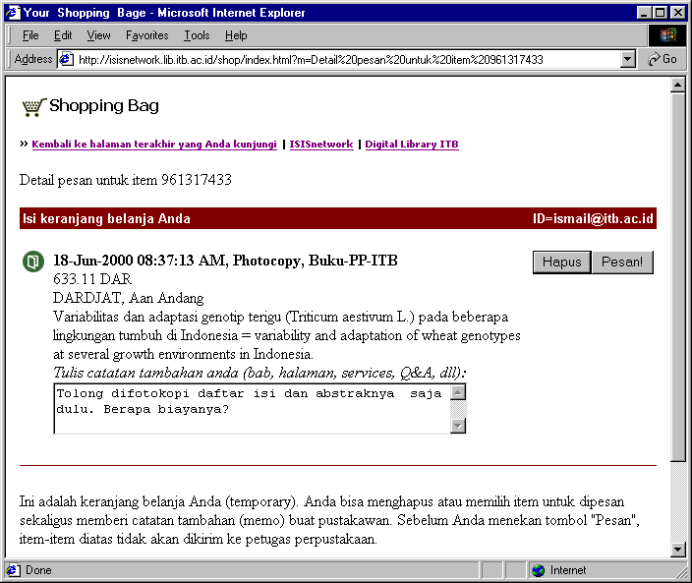
- Eureka… your library is now have an online services and business that create fund.

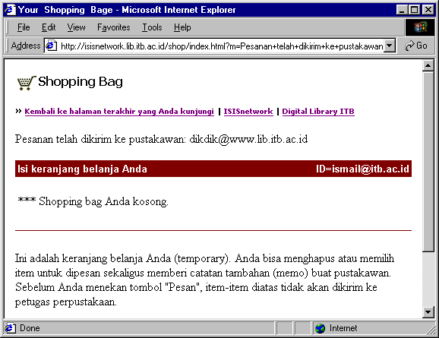

How to publish your CDS/ISIS databases?
It is very simple:
- Register your library:
online:
visit http://isisnetwork.lib.itb.ac.id
or contact us via phone/fax to:
Mr. Mahmudin
Email: mahmudin@www.lib.itb.ac.id
Phone/Fax: 022-2500089
Address: Perpustakaan Pusat ITB, Jl. Ganesha 10 Bandung
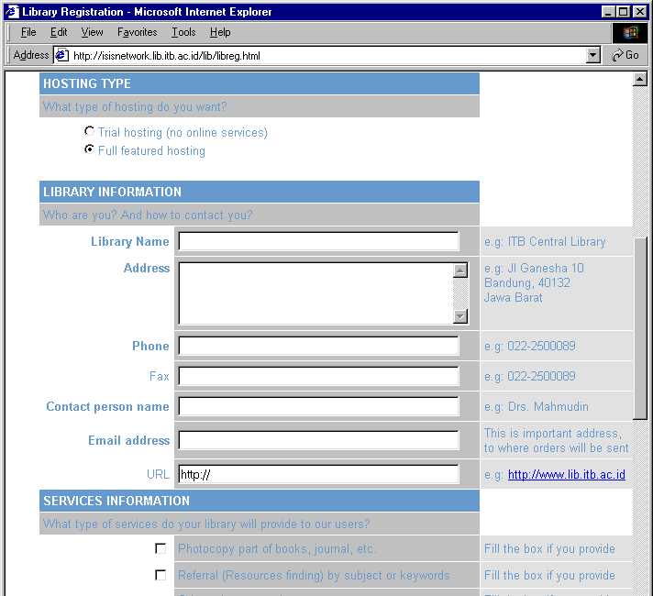
- Send your CDS/ISIS database file (compress in a zip file) to mahmudin@www.lib.itb.ac.id or send the disket to above address.
- Our administrator will configure the server for your library, and
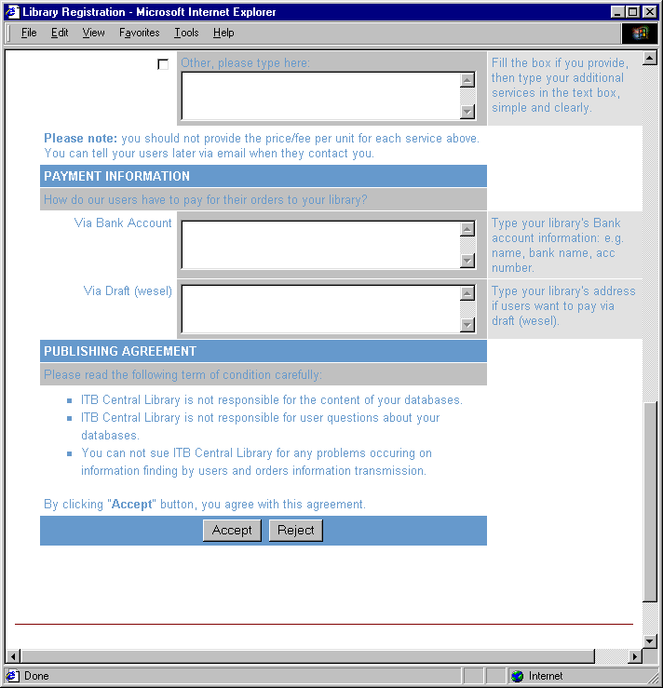
- Go live to Internet for your CDS/ISIS database.
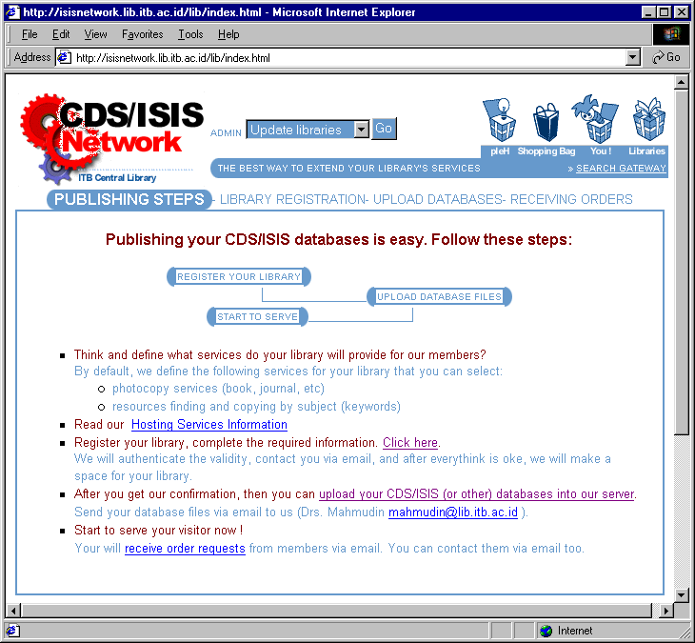

[6]
GNU-Lib,
Free-Software for Library Automation

Low cost, powerful, integrated with Internet, solution for Indonesian Libraries

© 2000, Knowledge Management Research Group (KMRG) ITB

What is Free-Software?

Free-Software is a philosophy. It states that software in this world should be “free”. Free here means “freedom”. Users of the software should have freedom to use it, install it, give it to neighbor, modify it, cannibalize some parts of it to create a new software, etc. Please note, that “free” doesn’t mean “gratis”, “no charge”, or “zero fee”. It is a freedom that users get when using the software.

We may sell the software, but we also have license to copy, distribute, modify, etc. We may give it away without any charge. Examples of the software are FreeBSD, Linux and other applications within them.

What is GNU-Lib?
GNU-Lib is a name of project by KMRG, ITB Central Library. Objective of this project is to develop a Free-Software for Indonesian libraries that works as library automation.

This software will be freely distributed to Indonesian libraries.

Who Provides Funding for this Project?
The initial funding of GNU-Lib version 1.0 will be handle by ITB. In the future, maintenance of the software should be self-funded by KMRG, ITB Central Library, together with Indonesian libraries communities that take advantages from the software.

What features of GNU-Lib?
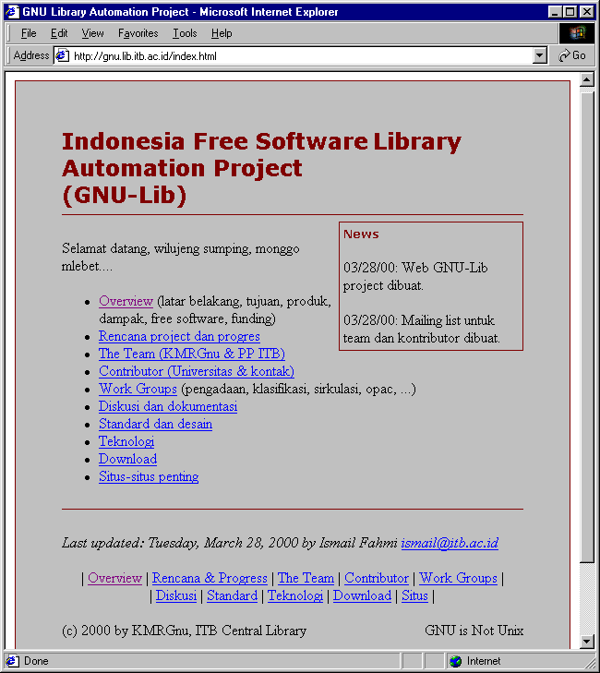
GNU-Lib will have the following features:
- Typical library automation workflow (circulation, OPAC, cataloguing, fine, etc)
- Integrated with Internet.
- Integrated with Barcode reader & printer.
- Online access via web browser for OPAC, reservation, renewal, fine, etc.
- Email alert for member that have email address.

Can I use the software for my library now?
Not yet. The first implementation will be tested at ITB Central Library on September 2000. After the test bed, software will be launched to public on October 2000. So, please be patient for now.

What requirements needed to run GNU-Lib?
The local area network topology needed in your library is as follow:

Hardware requirements
Server, minimum requirement:
- Pentium 100 MHz
- 32 MB Memory
- 4 GB HD
- Ethernet card

Client, minimum requirement:
- Processor 486
- 16 MB Memory
- No HD
- Ethernet card

Optional:
- Modem
- Internet connection to ISP

Software
Server:
- Operating system: Linux or Unix FreeBSD
- Database server: MySQL
- Scripting language: Perl
- Web server: Apache + PHP
- Mail server: Qmail

Client:
- DOS with TCP/IP application.
- Optional for barcode printing, using Windows 95.

