Automatic frequency controlled antenna switch

At the keyboard, M0DFI / Dan

There are many schematics and designs around for antenna switches. I needed an antenna switch that could be mounted, unattended in a mast or close to the antennas. However, as I didn't want to run more than one quality coax cable, I wanted a clean design with no fancy buttons or comms cables between the remotely located antenna switch and any control units in my shack.
Another very important factor was the price and complexity – any ham should be able to reproduce this gear and also modify it.

The initial design was made some years ago so I'm currently collecting (searching) the well spread bits of data and information I have regarding this project. I'm presenting this “interim” specification and are also open for any suggestions of mods and improvements.

What I wants from my Antenna Switch:

DC injected on the Coax, no extra cables to the switch.
Cheap. ( Cheapo relays will do in most cases )
0.1MHz to 30MHz minimum and possibly up to 50MHz. ( A special version for VHF/UHF )
Microprocessor control for flexibility, a simple PIC16F84 is enough,
Fully automatic. I don't want to switch antenna manually, just transmit.

So, after some cannibalizing on the net, using a simple PIC frequency counter as a base for the design, this is what I came up with.

Processor – PIC16F84
5V or 12V DC Injection on Coax
Initially 4 antenna choices

To select antenna, just transmit on the frequency corresponding to the particular antenna port according to the PIC program.
If you are using split frequency/band, you have to modify the program.

The first prototype looks vaguely like this

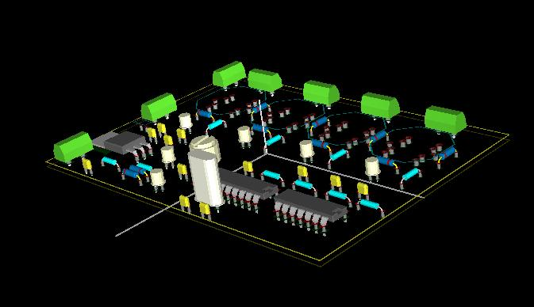
The green blobs are connectors and all of the connectors up and right are PL239's. The Processor part of the board have to be shielded in a sheet metal box which is thoroughly grounded.
The octagonal structures up and right are the relays.

I'm also including this early schematic but want to remind you about that I'm currently in the process of changing the design.

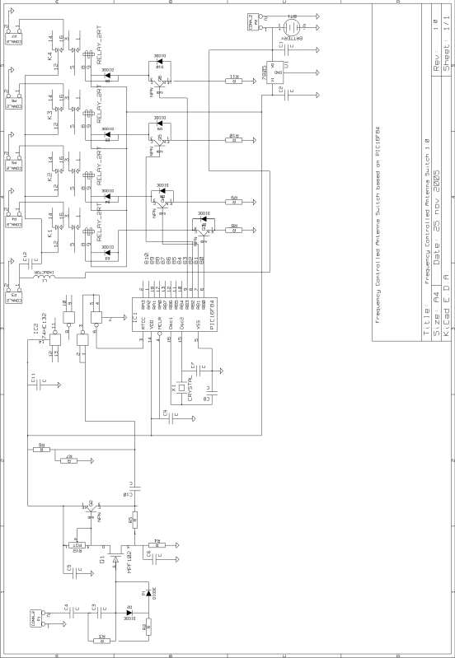
All schematics and PCB designs are made using a GPL'ed tool named KiCAD. This versatile tool is available free of charge for both Linux and Windows.

More on the design will be forwarded as soon as I been making further progress with it. However, I think this basic information will give the reader a good starting point if you are in a hurry to build something like this by yourself.

Cheers

Dan, M0DFI dan@andersson.co.uk

