The ladder filter experiment.

In his article “Ladder Crystal Filter Design” in QST November 1980, G3JIR described a way to calculate the C’s for a ladder filter. The article is posted in the File-box of the BITX20-group. He described how you can do systematic measurements on a 2nd-order filter in order to calculate the C’s for higher order design:

- Built a 2nd-order test circuit and start with C’s of 33pF.
- Make a frequency response curve and measure the band-width.
- The new C’s can be calculated: C_{new} = C_{old} * (BW_{found}/BW_{desired})²
- If the new C gives the desired bandwidth, the impedance can be calculated en used to calculate the C’s of the higher order filter.

In the 80”s it was impossible for me to make a frequency response curve of a filter but now with the computer and Spectrum Analyzer of PA2OHH it is not so difficult anymore. I was wondering if the described steps would lead to a usable ladder filter.

First I selected the crystals for the filter (see also the Excel file), second I built a demodulator with an computer interface. After that the 2nd order test circuit:

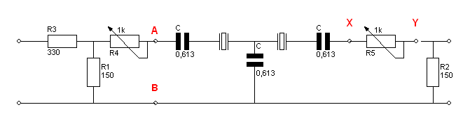

The noise generator was already there. The BFO frequency in the demodulator was tuned at exact: 9.005MHz.

First attempt:

 | 1e berekeningsronde:
 | Center freq: | 9,017 | MHz | R = | 328 | Ohm | Cstart: | 33 | pF
 | Freq-3dB: | 9,015 | MHz | Bw1: | 0,0040 | MHz | Cnieuw: | 92 | pF
 | Freq-3dB: | 9,019 | MHz | Bw2 | 0,0024 | MHz

The pictures:

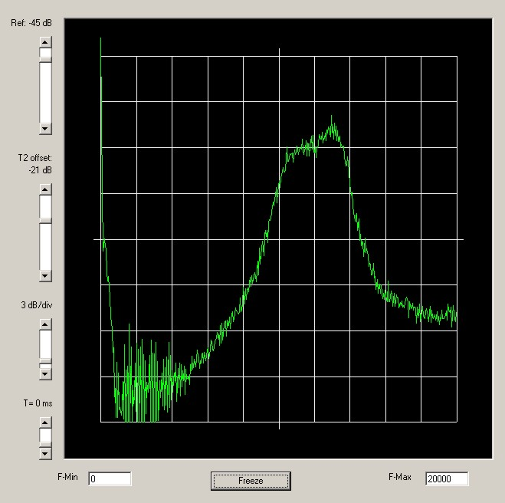

Second attempt:

 | 2e berekeningsronde:
 | Center freq: | 9,015 | MHz | R = | 122 | Ohm | Cstart: | 89 | pF
 | Freq-3dB: | 9,014 | MHz | Bw1: | 0,0020 | MHz | Cnieuw: | 62 | pF
 | Freq-3dB: | 9,016 | MHz | Bw2 | 0,0024 | MHz

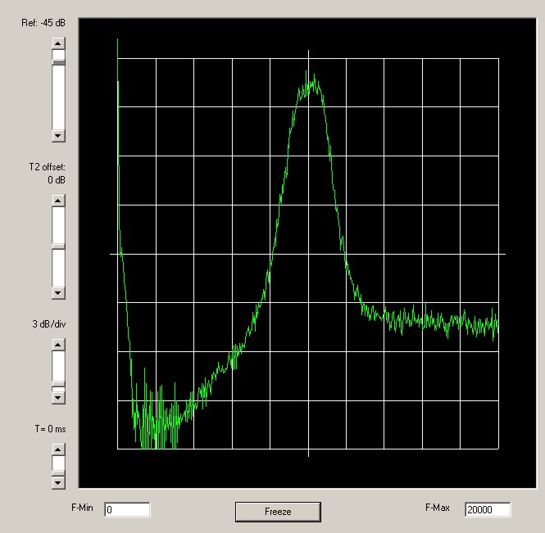
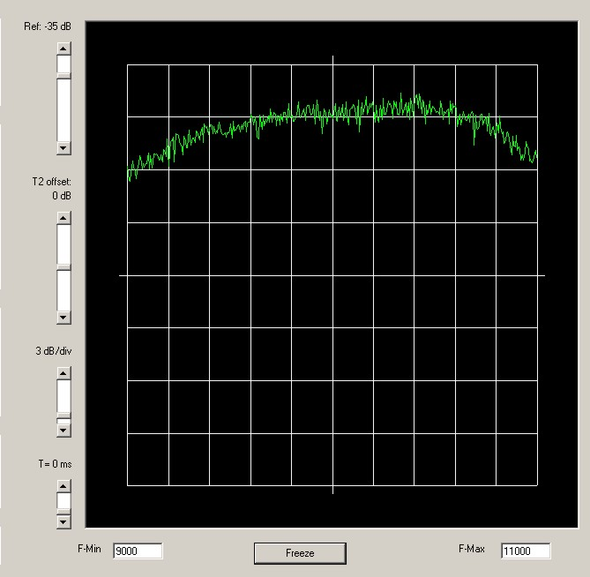

Third attempt:

 | 3e berekeningsronde:
 | Center freq: | 9,0155 | MHz | R = | 180 | Ohm | Cstart: | 60 | pF
 | Freq-3dB: | 9,0143 | MHz | Bw1: | 0,0027 | MHz | Cnieuw: | 76 | pF
 | Freq-3dB: | 9,017 | MHz | Bw2 | 0,0024 | MHz

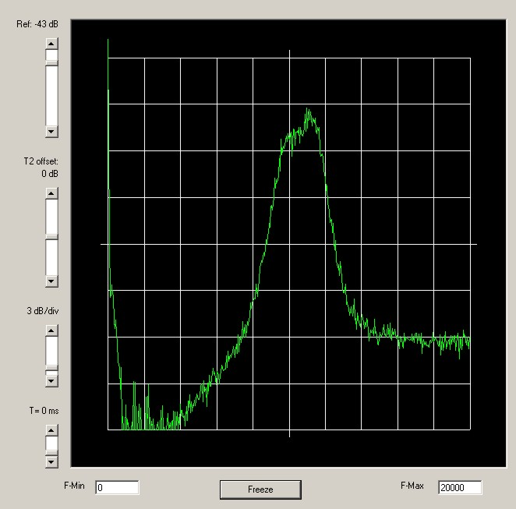
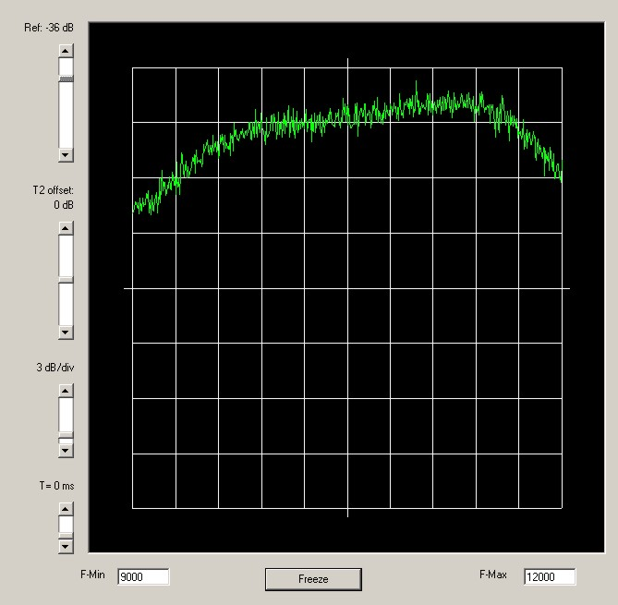

Fourth attempt:

 | 4e berekeningsronde:
 | Center freq: | 9,0153 | MHz | R = | 142 | Ohm | Cstart: | 76 | pF

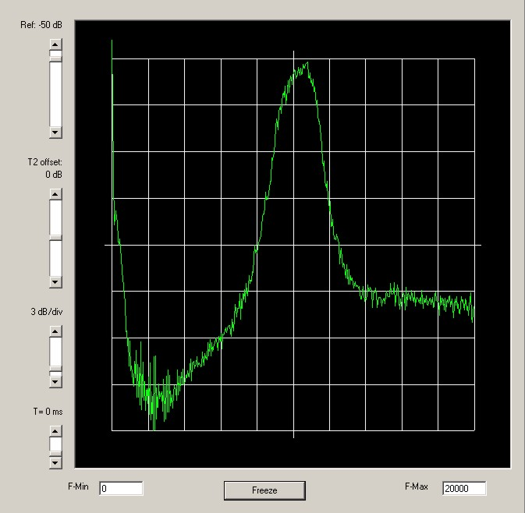
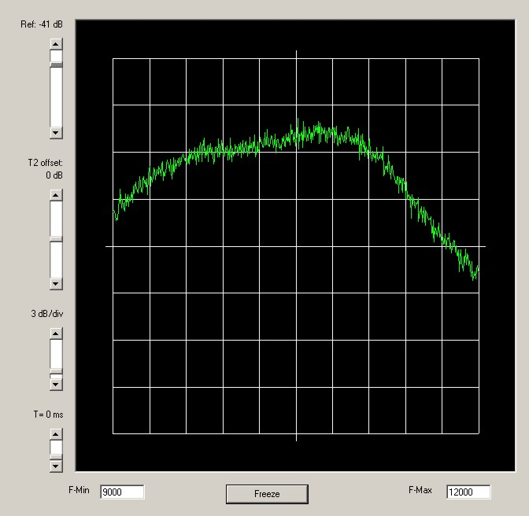

As you can see As you can see from the pictures the bandwidth is now about: 2,2 kHz. I was satisfied with the values I found. I used the impedance of the filter (R-value) to calculate the C’s for the 4th-order filter:

4th Order filter
R= | 142 | Ohm | Center freq: | 9,0153 | MHz
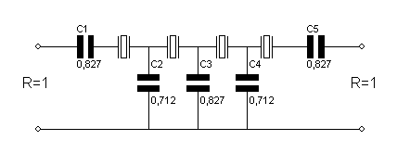
Type 1:

C1= C3 = C5: | 103 | pF
C2 = C4: | 89 | pF

I built the 4th order filter but I also included small L’s and Variable C’s (trimmers) impedance matches by the input and the output of the filter. After searching for the right C’s and L’s I got the following curves:

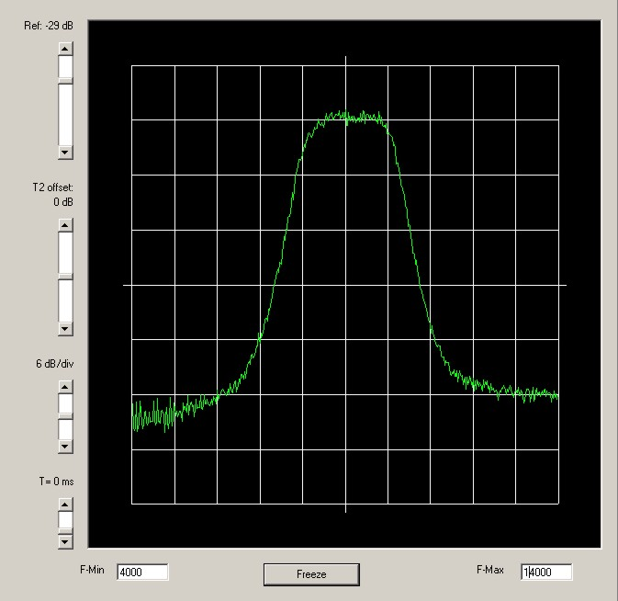

As you can see the bandwidth is about 2,2 kHz, the centre frequency is near 9.015MHz.I am satisfied with the result but the influence of the impedance matching is great. Here you can see the curves with and without matching (red is without matching):

Conclusion:
- The method G3JIR described did work out for my 4th-order filter. It looks like it still is actual and can be used by amateurs with simple measure equipment.
- The experiment learned me how important the impedance matching is. It has great influence on the shape and the centre frequency of the filter.
- I agree with Max, message 911, without measuring the shape of the filter building one looks like a lottery.

73,

Ruud
PE2BS

