RS232 INTERFACE

It is reminded that if the user don’t dispose of the VOX function (or does not want to use it), it is possible to control the PTT terminals of the transceiver by one of the DTR/RQS pin of a serial port (COM 1 to 4).
For this, a menu gives the ability to choice between COM 1 and COM 4. The user must chech the serial port with the option “Checking of the selected serial port (“Actions” menu).

Two examples of interface are given hereafter. They come from the interface of F1ULT published in RADIO-REF of september 2000.
The first type is used if the PTT withhands a weak but not nil potential barrier (due to the photo-coupler transistor): this is the case for KENWOOD TS-440S. The second type is used if PTT requires a “dry” contact sec: for example the IC 706.

FIRST TYPE OF INTERFACE
For transceiver of TS-440S Kenwood type, it may be used the following interface:
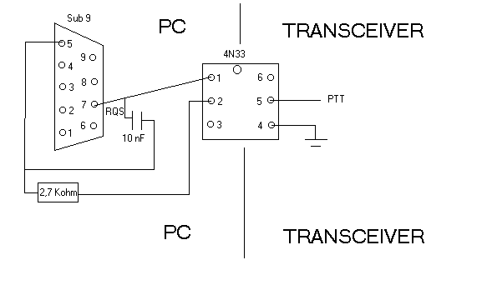
The Sub9 female connector is seen from the pins to weld. The pin number 5 is the logical ground. The RQS pin passes about -10 V in “Translation” mode to 10 V in "Edition" mode.

The 4N33 is a Darlington photo-coupler.

On Kenwood TS-440S, the PTT pin (for PTT foot switch) is situated on the REMOTE connector on the rear panel of the transceiver.

SECOND TYPE OF INTERFACE
For transceiver IC706 type, the contact must be or open or closed but without any potential barrier. It may be used the following interface. Of course, this interface may be also used for Kenwood TS440S.

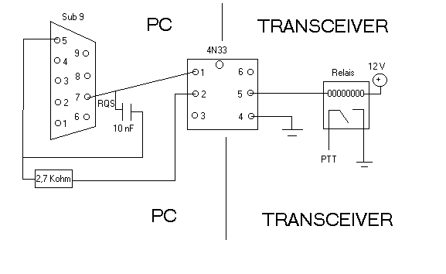
I put the biggest relay i had (un SGR 662 d’ELESTA).
The 13,8 V issued from the IC706 must not be used. An independant 12 V source must be used (a little 12 V supply block).

For the IC706MK2G the 3 grounds (from PTT and from lines coming from the sound card) go to pin 2 of the DATA connector. The PTT goes to the pin 3, the line from the sound card receiving BF goes to the pin 5 and the last line from sound card (active in transmission) goes to the pin 1.

